VEDAS COLLEGE
AFFILIATED TO TRIBHUVAN UNIVERSITY
JAWALAKHEL, LALITPUR, Nepal




A
Lab Report
On
Simulation and Modelling
(CSC328)

Submitted By: Submitted To:
Name: Prajwal Chaulagain Instructor: Suvash Khadka
Symbol No: 80010773
Semester: Fifth
Faculty: Science and Technology
Level: Bachelor
Program: Computer Science and Information Technology.

2026
Table of Contentss

S.N. | Lab Title | Signature
1. | Random Number Generation using MS-Excel Function.
2. | Distributed Lag Model using C Program.
3. | Linear Congruential Method using C Program.
4. | Kolmogorov-Smirnov Test using C Program.
5. | Chi-Square Test using C Program.
6. | Gap Test using C Program.
7. | Auto-Correlation Test using C Program.
8. | Poker Test (Three-digit & Four-digit) using C Program.
9. | GPSS Blocks.
10. | GPSS For Implement of Simulation Models.  10.1 Barber Shop.  10.2 Mechanic on Service.  10.3 Manufacturing Shop.  10.4 Restaurant Service.  10.5 Ticketing System.
11. | Random Number Generation using C Program.
12. | Monte Carlo Simulation of Dice Game using C Program.
13. | Monte Carlo Simulation to Estimation the Circumference of a Circle using C Program.
14. | Monte Carlo Simulation to Estimation the Circumference of a Circle using MS-Excel Function.

1. Generate the random numbers using MS-Excel Function.
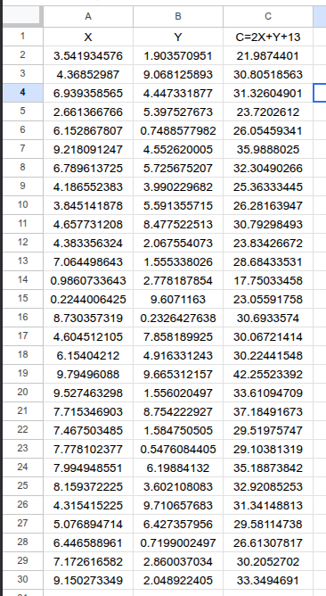

Output:-
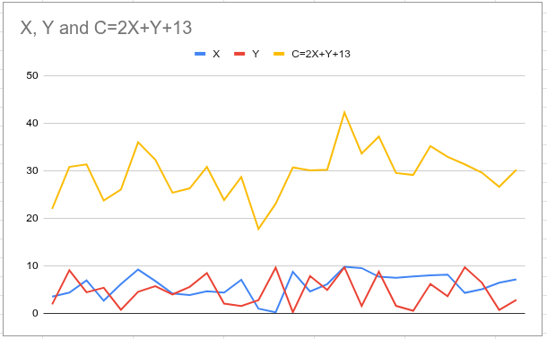

2. Write a C program to find the growth in national consumption for five years using Distributed Lag Model given below:
I = 2 + 0.1 Y1
Y = 45.45 + 2.27 (I +G)
T = 0.2 Y
C = 20 + 0.7 (YT)
Assume the initial value of Y1 is 80 and take the governmental expenditure in the 5 years to be as follows:
Year G
1 20
2 25
3 30
4 35
5 40

(i). Program:
#include <stdio.h>
int main()
{
int year;
double Y1 = 80;
double G[5] = {20, 25, 30, 35, 40};
double I, Y, T, C;
printf("Year\tG\tI\tY\tT\tC\n");
for (year = 0; year < 5; year++)
{
I = 2 + 0.1 * Y1;
Y = 45.45 + 2.27 * (I + G[year]);
T = 0.2 * Y;
C = 20 + 0.7 * (Y - T);
printf("%d\t%.2f\t%.2f\t%.2f\t%.2f\t%.2f\n", year + 1, G[year], I, Y, T, C);
Y1 = Y;
}
return 0;
}

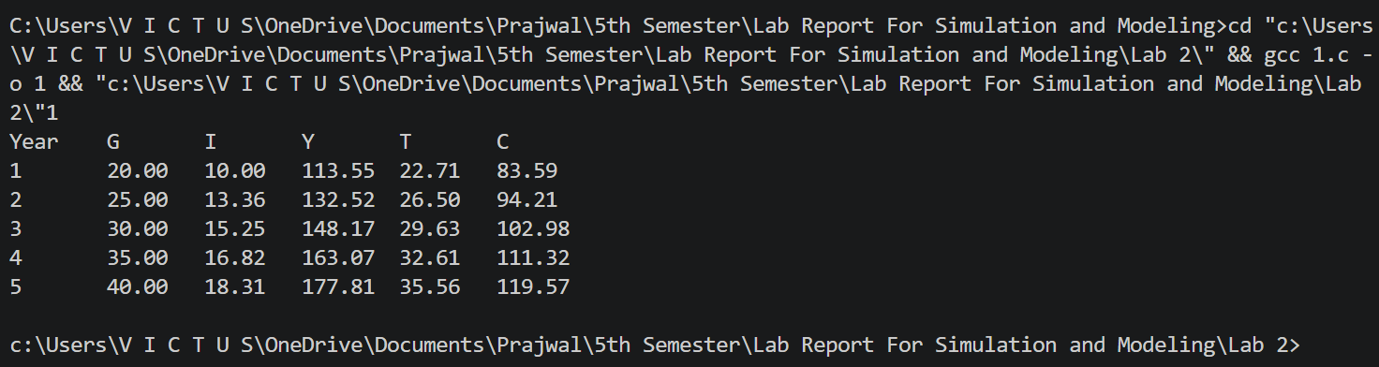
(ii). Output:

3. Write a C program to generate the random numbers using linear congruential generator method.
(i). Program:
#include <stdio.h>

int main()
{
long long x0, a, c, m;
int n;

printf("Enter the seed value (x0): ");
scanf("%lld", &x0);

printf("Enter the multiplier (a): ");
scanf("%lld", &a);

printf("Enter the increment (c): ");
scanf("%lld", &c);

printf("Enter the modulus (m): ");
scanf("%lld", &m);

if (m <= 0)
{
printf("Modulus must be greater than 0\n");
return 1;
}
printf("How many random numbers to generate? ");
scanf("%d", &n);

printf("Generated random numbers:\n");
for (int i = 0; i < n; i++)
{
x0 = (a * x0 + c) % m;
float r = (float)x0 / m;
printf("%f\n", r);
}
return 0;
}

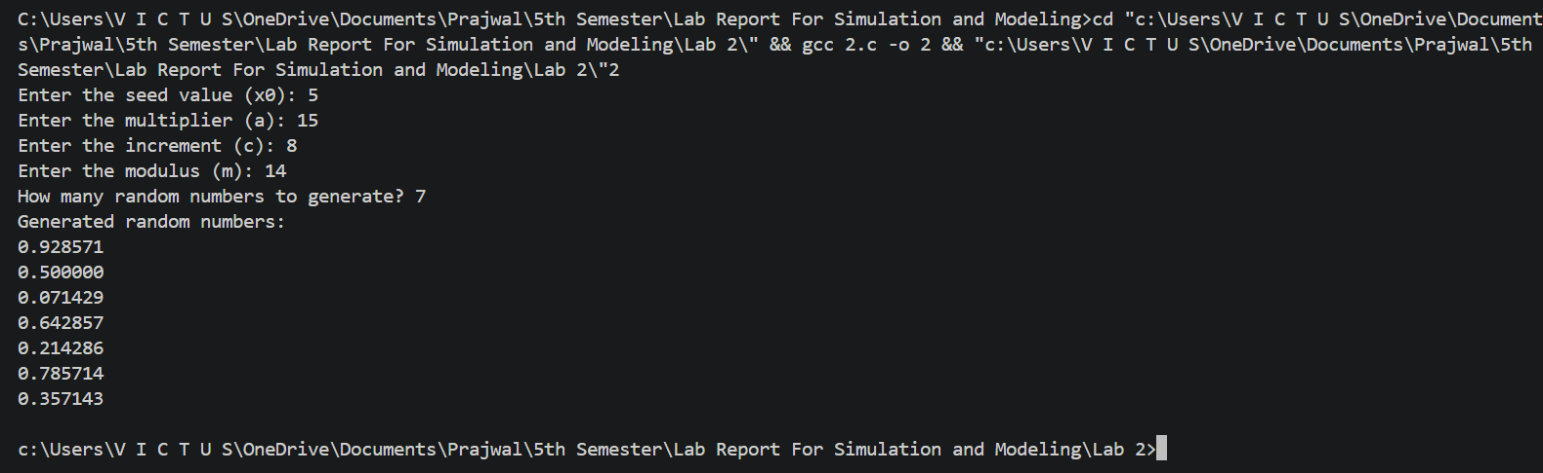
(ii). Output:

4. Write a C program to implement the Kolmogorov-Smirnov Test.
(i). Program:
#include <stdio.h>
#include <math.h>

void sort(float x[], int n)
{
float temp;
for (int i = 0; i < n - 1; i++)
{
for (int j = 0; j < n - i - 1; j++)
{
if (x[j] > x[j + 1])
{
temp = x[j];
x[j] = x[j + 1];
x[j + 1] = temp;
}
}
}
}
int main()
{
int n;
float x[100], d_plus = 0, d_minus = 0, d, d_crit;

printf("Enter number of observations: ");
scanf("%d", &n);

printf("Enter the data (values between 0 and 1):\n");
for (int i = 0; i < n; i++)
{
scanf("%f", &x[i]);
}
sort(x, n);

for (int i = 0; i < n; i++)
{
float d1 = ((float)(i + 1) / n) - x[i];
float d2 = x[i] - ((float)i / n);

if (d1 > d_plus)
d_plus = d1;

if (d2 > d_minus)
d_minus = d2;
}
d = (d_plus > d_minus) ? d_plus : d_minus;
d_crit = 1.36 / sqrt(n);
printf("\nD+ = %f", d_plus);
printf("\nD- = %f", d_minus);
printf("\nD = %f", d);
printf("\nCritical Value = %f\n", d_crit);
if (d < d_crit)
printf("Result: Accept Null Hypothesis (Good fit)\n");
else
printf("Result: Reject Null Hypothesis (Not a good fit)\n");
return 0;
}

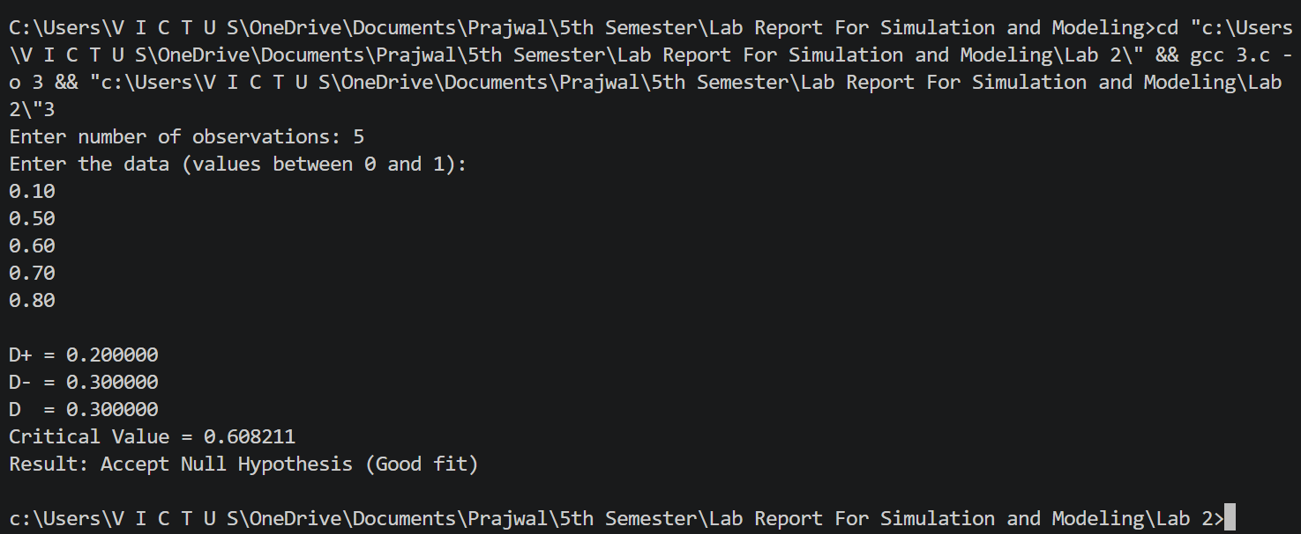
(ii). Output:

5. Write a C program to implement the Chi-Square Test.
(i). Program:
#include <stdio.h>
#include <math.h>

int main()
{
int n, i;
double observed[100], expected[100], chi_square = 0.0;
printf("Enter the number of categories: ");
scanf("%d", &n);
printf("Enter the observed frequencies:\n");
for (i = 0; i < n; i++)
{
scanf("%lf", &observed[i]);
}
printf("Enter the expected frequencies:\n");
for (i = 0; i < n; i++)
{
scanf("%lf", &expected[i]);
}
for (i = 0; i < n; i++)
{
chi_square += pow(observed[i] - expected[i], 2) / expected[i];
}
printf("Chi-Square Statistic: %.2lf\n", chi_square);
return 0;
}

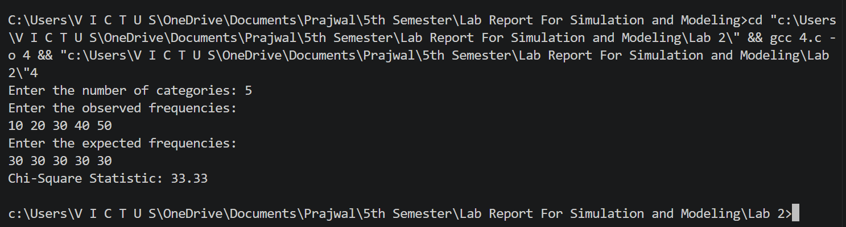
(ii). Output:

6. Write a C program to implement Gap Test.
(i). Program:
#include <stdio.h>
int main() {
int n, i, key;
int arr[100];
printf("Enter number of elements in sequence: ");
scanf("%d", &n);
printf("Enter the sequence (0-9 numbers):\n");
for (i = 0; i < n; i++) {
scanf("%d", &arr[i]);
}
printf("Enter the digit to test (0-9): ");
scanf("%d", &key);
int last_index = -1;
int gap_count = 0;
printf("\nGaps between occurrences of %d:\n", key);
for (i = 0; i < n; i++) {
if (arr[i] == key) {
if (last_index != -1) {
printf("Gap %d: %d\n", gap_count + 1, i - last_index - 1);
gap_count++;
}
last_index = i;
}
}
if (gap_count == 0) {
printf("Not enough occurrences of %d to compute gaps.\n", key);
}
return 0;
}

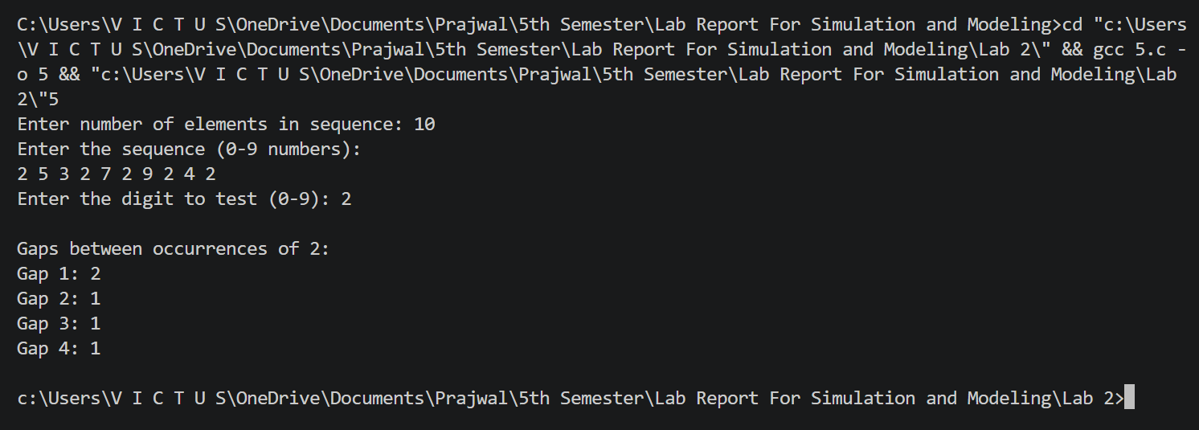
(ii). Output:

7. Write a C program to implement Auto Correlation Test.
(i). Program:
#include <stdio.h>
#define MAX 100
int main()
{
int n, i, k;
double data[MAX], mean = 0.0;
double numerator = 0.0, denominator = 0.0;
printf("Enter number of data points: ");
scanf("%d", &n);
printf("Enter the data values:\n");
for (i = 0; i < n; i++)
{
scanf("%lf", &data[i]);
mean += data[i];
}
mean /= n;
printf("Enter lag (k): ");
scanf("%d", &k);
if (k >= n || k < 0)
{
printf("Invalid lag.\n");
return 1;
}
for (i = 0; i < n - k; i++)
{
numerator += (data[i] - mean) * (data[i + k] - mean);
}
for (i = 0; i < n; i++)
{
denominator += (data[i] - mean) * (data[i] - mean);
}
double autocorr = numerator / denominator;
printf("Autocorrelation at lag %d = %lf\n", k, autocorr);
return 0;
}

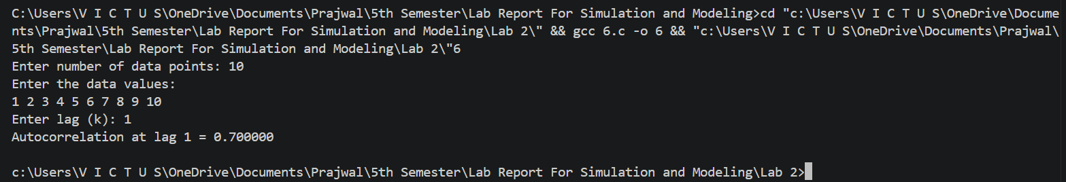
(ii). Output:

8. Write a C program to implement Poker Test (For Three digit and Four Digit).
(i). Program:
#include <stdio.h>
#include <string.h>
void analyze(int num[], int n, int *counts)
{
int freq[10] = {0};
int pair = 0, triple = 0, four = 0;
for (int i = 0; i < n; i++)
{
if (num[i] >= 0 && num[i] <= 9)
{
freq[num[i]]++;
}
}
for (int i = 0; i < 10; i++)
{
if (freq[i] == 4) four++;
else if (freq[i] == 3) triple++;
else if (freq[i] == 2) pair++;
}
if (four) counts[4]++;
else if (triple) counts[3]++;
else if (pair == 2) counts[2]++;
else if (pair == 1) counts[1]++;
else counts[0]++;
}
int main()
{
int n, digits;
int counts[5] = {0}; // all_diff, one_pair, two_pairs, three_kind, four_kind
printf("Enter number of random numbers: ");
scanf("%d", &n);
printf("Enter number of digits (3 or 4): ");
scanf("%d", &digits);
if (digits != 3 && digits != 4)
{
printf("Invalid digit size. Only 3 or 4 allowed.\n");
return 0;
}
int num[4];
for (int i = 0; i < n; i++)
{
printf("\nEnter %d digits (0-9): ", digits);
for (int j = 0; j < digits; j++)
scanf("%d", &num[j]);
analyze(num, digits, counts);
}
printf("\n--- Poker Test Results ---\n");
printf("All Different : %d\n", counts[0]);
printf("One Pair : %d\n", counts[1]);
if (digits == 4)
{
printf("Two Pairs : %d\n", counts[2]);
printf("Three of a Kind : %d\n", counts[3]);
printf("Four of a Kind : %d\n", counts[4]);
}
else
{
printf("Three of a Kind : %d\n", counts[3]);
}
return 0;
}

(ii). Output:
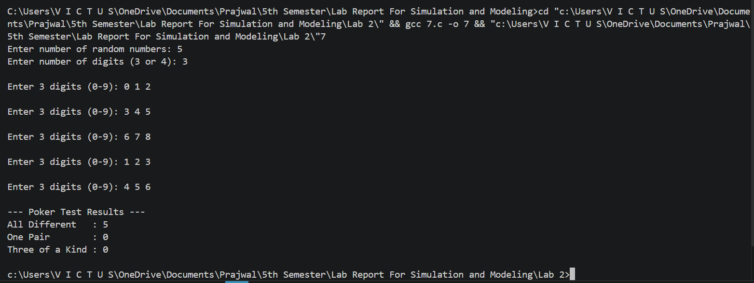

9. Explain GPSS blocks (major blocks that we use commonly).
General Purpose Simulation System:-
GPSS is a discrete time simulation general-purpose programming language where a simulation clock advances in discrete steps. A system is modeled as transactions enter the system and are passed from one service to another. This is particularly well suited for problems such as factory. GPSS is less flexible than simulatin lauguages such as Simula and SIMSCRIPT but it is eaiser to use and most popular.
GPSS was designed especially for analysis who were not necessary computer programmer. It is particularly suited for modeling traffic and queuing systems. A GPSS programmer does not write a program in some sense as SIMSCRIPT programmer does, instead the constructs a blocks each performing a special simulation oriented function.
GPSS provides a set of 48 different blocks to choose from each of which can be used repeatedly. Each blocks has a name and specific task to perform. Moving through the system of block are entities called transaction are customer, messenger, machine etc.
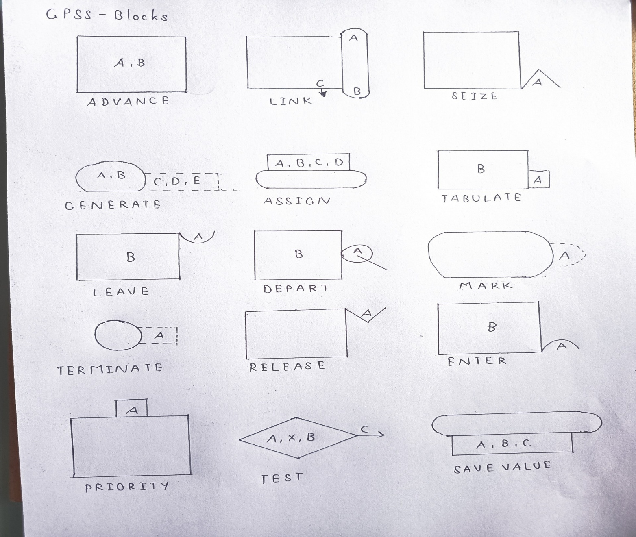
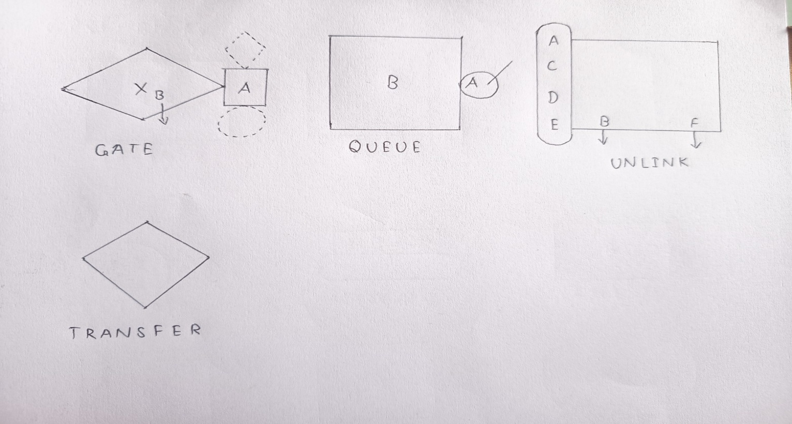

10. Using GPSS, implement the following simulations.
10.1 Barber Shop.
(i). Program:
GENERATE 5,2
QUEUE BARBERQ
SEIZE BARBER
DEPART BARBERQ
ADVANCE 6,3
RELEASE BARBER
TERMINATE 1

(ii). Output:
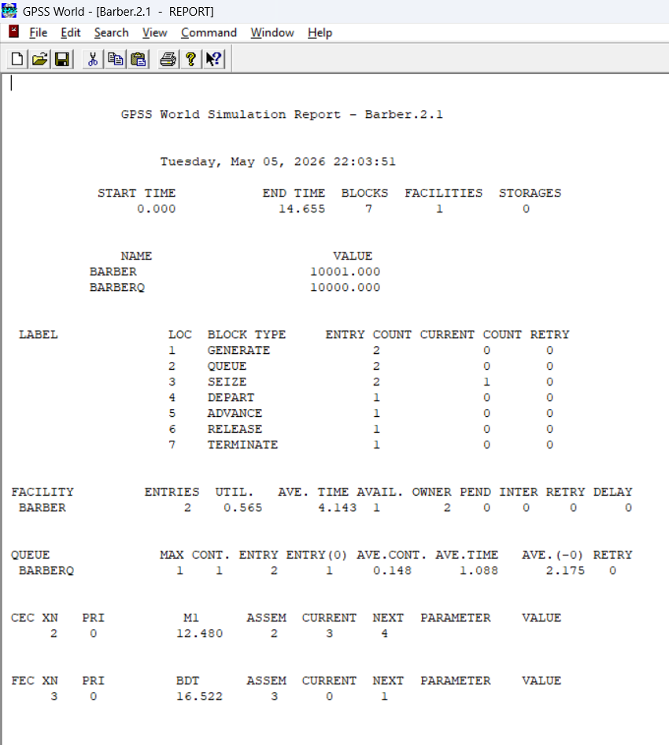

10.2 Mechanic on Service.
(i). Program:
GENERATE 15,5
QUEUE REPAIRQ
SEIZE MECHANIC
DEPART REPAIRQ
ADVANCE 12,4
RELEASE MECHANIC
TERMINATE 1

(ii). Output:
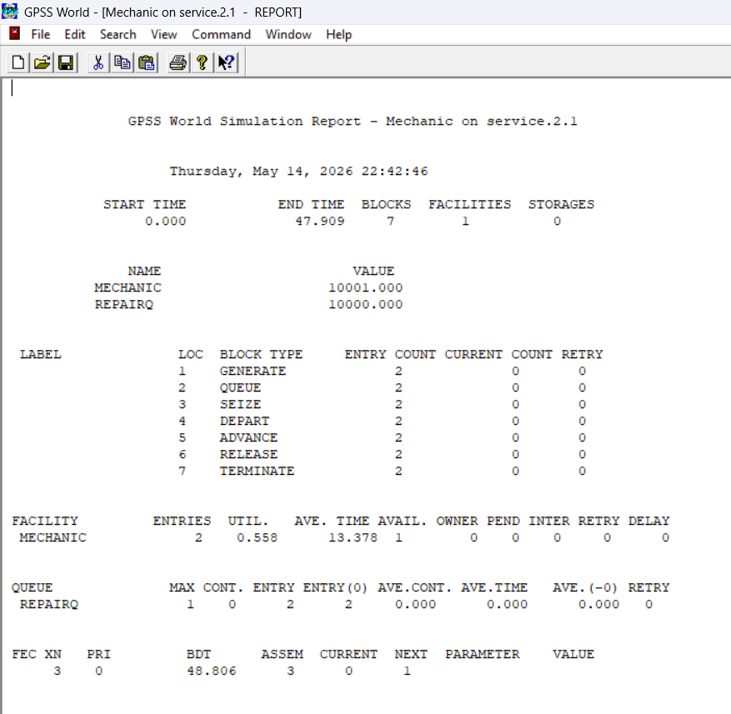

10.3 Manufacturing Shop.
(i). Program:

GENERATE 10,3
QUEUE MILL_Q
SEIZE MILL
DEPART MILL_Q
ADVANCE 8,2
RELEASE MILL
QUEUE DRILL_Q
SEIZE DRILL
DEPART DRILL_Q
ADVANCE 6,2
RELEASE DRILL
QUEUE INSPECT_Q
SEIZE INSPECTOR
DEPART INSPECT_Q
ADVANCE 4,1
RELEASE INSPECTOR
TERMINATE 1

(ii). Output:
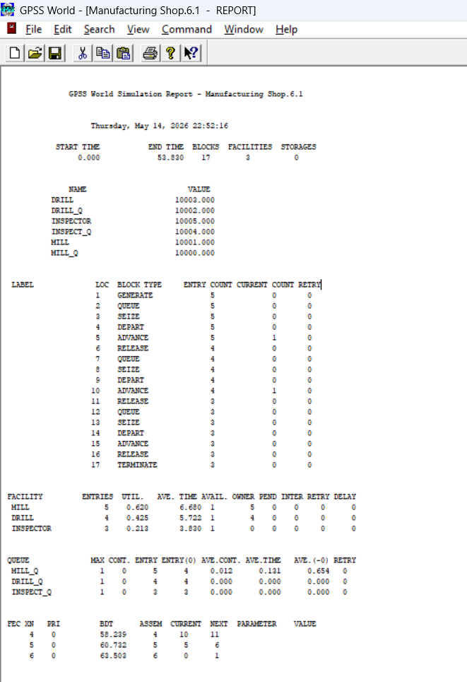

10.4 Restaurant Service.
(i). Program:
GENERATE 5,2
QUEUE WAIT_SEAT
SEIZE SEAT
DEPART WAIT_SEAT
ADVANCE 15,5
RELEASE SEAT
QUEUE WAIT_PAY
SEIZE CASHIER
DEPART WAIT_PAY
ADVANCE 2,1
RELEASE CASHIER
TERMINATE 1

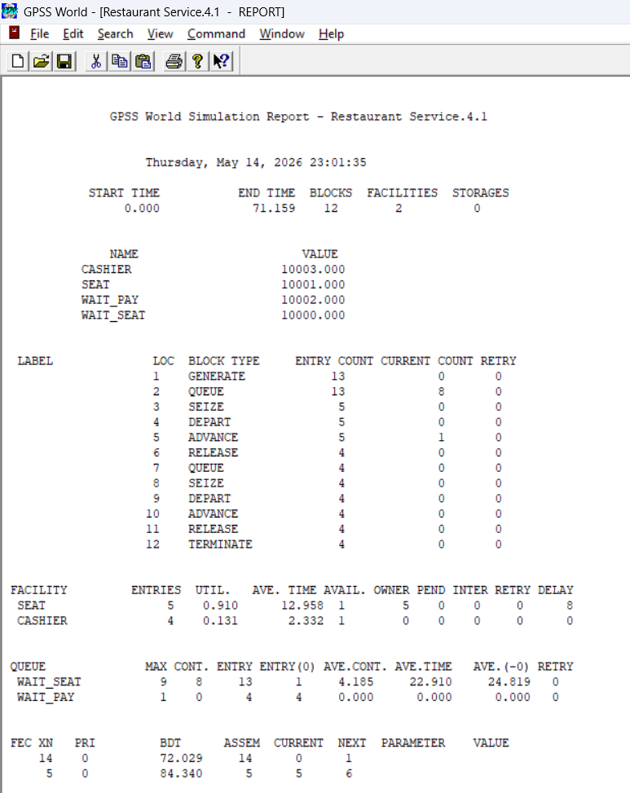
(ii). Output:
10.5 Ticketing System.
(i). Program:
GENERATE 4,2
QUEUE Q_TICKET
SEIZE TICKET_WIN
DEPART Q_TICKET
ADVANCE 5,2
RELEASE TICKET_WIN
TERMINATE 1

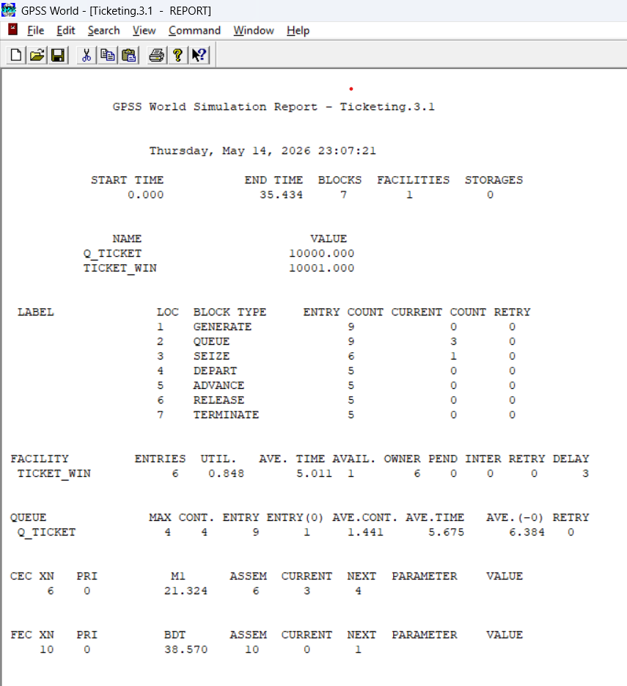
(ii). Output:
11. Write a C program to simulate games of dice that generate discrete random variate, using random number generation.
(i). Program:
#include <stdio.h>
#include <stdlib.h>
#include <time.h>
#define MAX_SUM 12

int rollDie() {
return 1 + (int)(6.0 * rand() / (RAND_MAX + 1.0));
}
int rollTwoDice() {
return rollDie() + rollDie();
}
void printFrequency(int freq[], int start, int end) {
printf("\n=== Frequency Distribution ===\n");
printf("Outcome Frequency Probability\n");
printf("----------------------------------\n");
int total = 0;
for (int i = start; i <= end; i++) {
total += freq[i];
}
for (int i = start; i <= end; i++) {
double prob = (total > 0) ? (freq[i] * 100.0 / total) : 0.0;
printf("%3d %12d %12.2f%%\n", i, freq[i], prob);
}
}
int main() {
srand((unsigned int)time(NULL));
int choice, numRolls;
printf("=== Dice Simulation ===\n");
printf("1. Single Die\n");
printf("2. Two Dice\n");
printf("Choice (1-2): ");
if (scanf("%d", &choice) != 1) {
printf("Invalid input!\n");
return 1;
}
printf("Number of rolls: ");
if (scanf("%d", &numRolls) != 1) {
printf("Invalid input!\n");
return 1;
}
if (numRolls <= 0) {
printf("Invalid number of rolls!\n");
return 1;
}
int *freq = calloc(MAX_SUM + 1, sizeof(int));
if (!freq) {
printf("Memory allocation failed!\n");
return 1;
}
int start = 0, end = 0;
switch (choice) {
case 1:
start = 1;
end = 6;
for (int i = 0; i < numRolls; i++) {
freq[rollDie()]++;
}
break;
case 2:
start = 2;
end = 12;
for (int i = 0; i < numRolls; i++) {
freq[rollTwoDice()]++;
}
break;
default:
printf("Invalid choice!\n");
free(freq);
return 1;
}
printFrequency(freq, start, end);
double mean = 0.0;
for (int i = start; i <= end; i++) {
mean += i * freq[i];
}
mean /= numRolls;
printf("\nTheoretical Mean: %.1f\n", (choice == 1) ? 3.5 : 7.0);
printf("Observed Mean : %.3f\n", mean);
free(freq);
return 0;
}

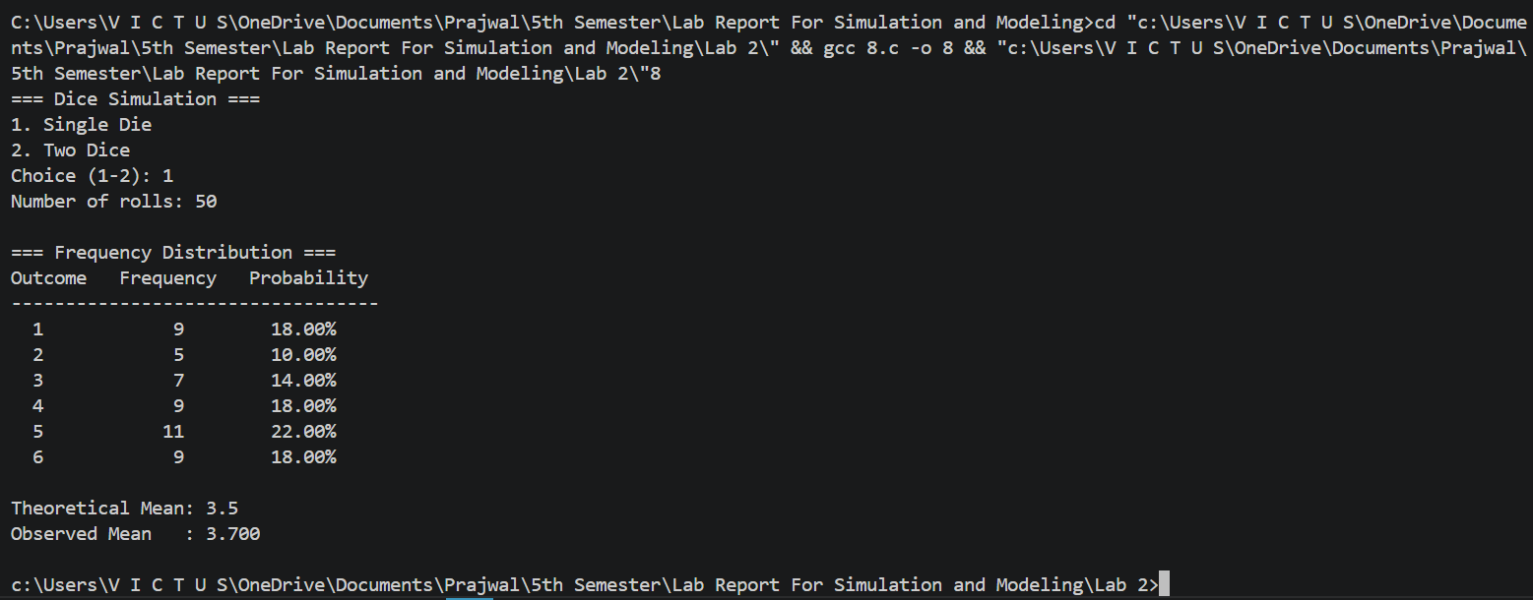
(ii). Output:
12. Write a c program to perform Monte Carlo simulations simulate games of dice by generating discrete random variates.
(i). Program:
#include <stdio.h>
#include <stdlib.h>
#include <time.h>

int main() {
int i, n;
int count[7] = {0};
int roll;
double average = 0;
printf("Enter number of simulations: ");
scanf("%d", &n);
srand(time(0));
for(i = 0; i < n; i++) {
roll = rand() % 6 + 1;
count[roll]++;
average += roll;
}
printf("\nResults after %d simulations:\n", n);
for(i = 1; i <= 6; i++) {
printf("Face %d occurred %d times (Probability = %.4f)\n",
i, count[i], (double)count[i]/n);
}
printf("\nAverage value = %.4f\n", average/n);
return 0;
}
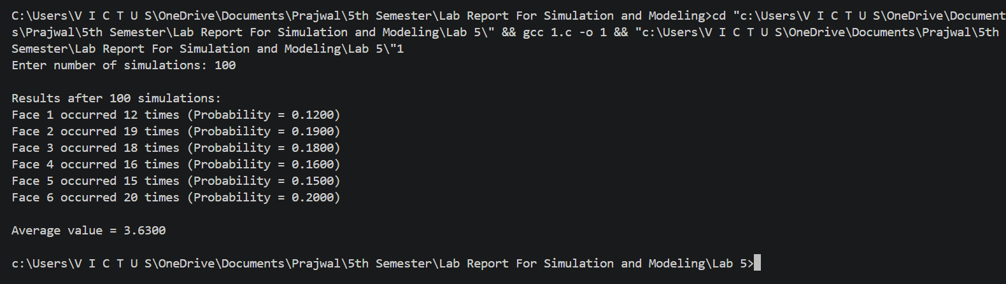
(ii). Output:

13. Write a c program to perform Monte Carlo Simulation to estimate the circumference of a circle.
(i). Program:
#define _USE_MATH_DEFINES
#include <stdio.h>
#include <stdlib.h>
#include <time.h>
#include <math.h>

int main() {
int n, i, count = 0;
double x, y, r, radius, thickness;
double circumference;
printf("Enter number of random points: ");
scanf("%d", &n);
printf("Enter radius of circle: ");
scanf("%lf", &radius);
printf("Enter thickness (small value like 0.01): ");
scanf("%lf", &thickness);
if (n <= 0 || radius <= 0 || thickness <= 0) {
printf("Invalid input.\n");
return 1;
}

srand((unsigned int)time(NULL));
for (i = 0; i < n; i++) {
// Generate random point in square [-r, r]
x = ((double)rand() / RAND_MAX) * 2 * radius - radius;
y = ((double)rand() / RAND_MAX) * 2 * radius - radius;
r = sqrt(x*x + y*y);
if (r >= radius - thickness && r <= radius)
count++;
}
double square_area = 4 * radius * radius;
circumference = (double)count / n * square_area / thickness;
printf("\nEstimated Circumference = %lf\n", circumference);
printf("Actual Circumference = %lf\n", 2 * M_PI * radius);
return 0;
}

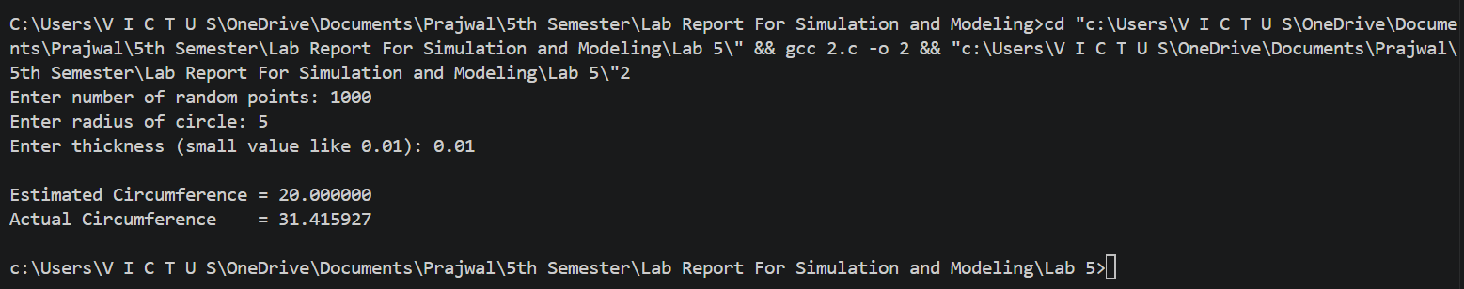
(ii). Output:

14. Monte Carlo Simulation to Estimation the Circumference of a Circle using MS-Excel Function.
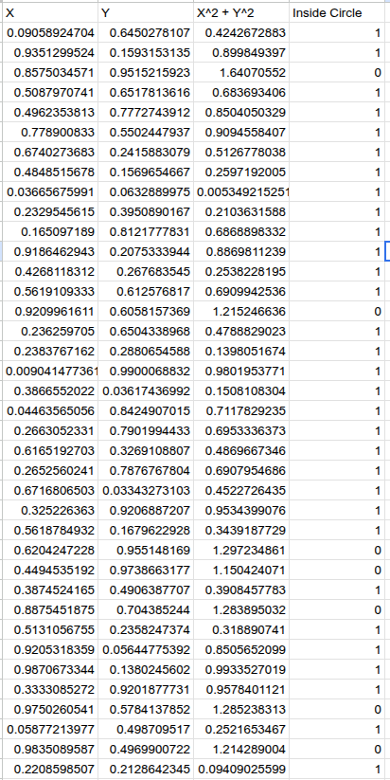

Output:-
